let's build a Congrats Card by applying the concepts we have learned till now



Image URLs

·       <https://assets.ccbp.in/frontend/react-js/congrats-card-bg.png>

·       <https://assets.ccbp.in/frontend/react-js/congrats-card-profile-img.png>

·      [https://assets.ccbp.in/frontend/react-js/congrats-card-watch-img.png](https://assets.ccbp.in/frontend/react-js/congrats-card-profile-img.png)

let's build a Super Over League by applying the concepts we have learned till now.



[• https://assets.ccbp.in/frontend/react-js/rcb-img.png](http://xn--https-ix3b/assets.ccbp.in/frontend/react-js/rcb-img.png)

[• https://assets.ccbp.in/frontend/react-js/csk-img.png](http://xn--https-ix3b/assets.ccbp.in/frontend/react-js/csk-img.png)

 let's build a Social Buttons by applying the concepts

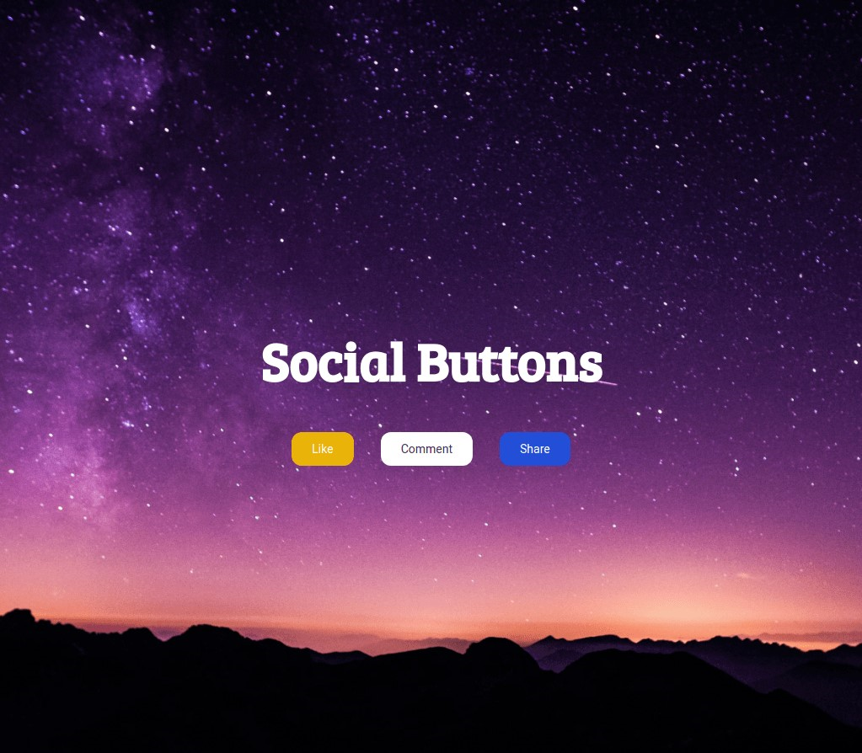

 let's build a Notifications app

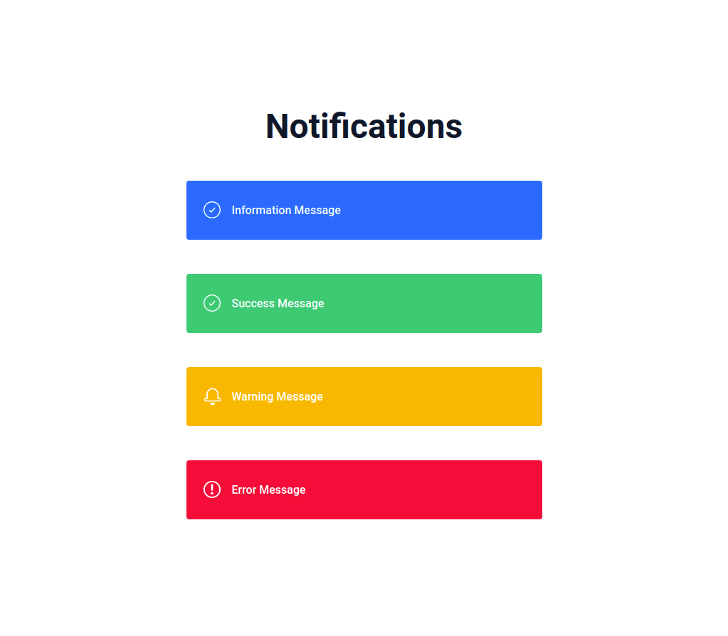

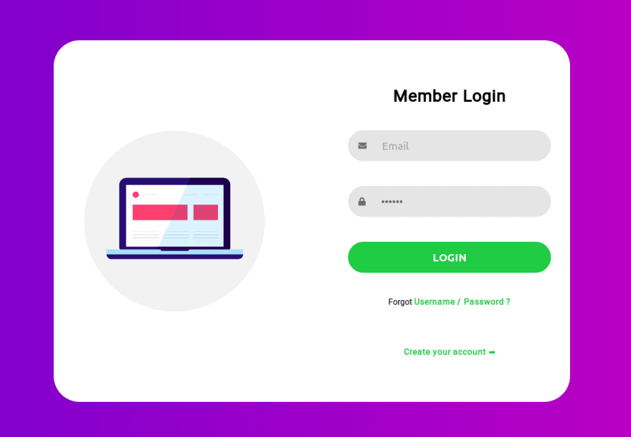

let's build Technology Cards by applying the concepts we have learned till now.

